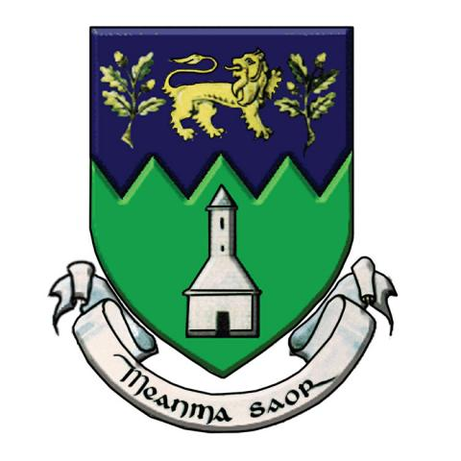

WICKLOW COUNTY COUNCIL

EXPRESSIONS OF INTEREST PROVISION OF “TURNKEY” HOUSING

Notice to Developer/Builders/Housing Bodies

Proposals are invited for the provision of housing units for social housing through “turnkey” developments throughout County Wicklow. This will be by way of acquisition only. The following will be decisive in the assessment of any proposals submitted:-

- Property Location & Social Housing Need
- Planning Status
- Value for money
- Compliance with the Department of Housing, Planning & Local Government Guidelines
- Timescale for delivery
- Financial Capacity
- Quality of Design and Construction

Proposals may provide for one, two, three or four bedroom units. Constructed or partly constructed projects will be considered. Interested parties are requested to complete an Expression of Interest Form available from the following link: http://www.wicklow.ie/expressions-interest-turnkey

Expressions of Interest forms should be submitted to Wicklow County Council, Station Road, Wicklow Town in a sealed envelope clearly marked “EXPRESSIONS OF INTEREST – TURNKEY DEVELOPMENTS”.

Wicklow County Council is subject to the provisions of the Freedom of Information (FOI) Act. If you consider that the information supplied by you is either commercially sensitive or confidential in nature, this would be highlighted and the reasons for its sensitivity specified. In such cases, the relevant material will, in response to FOI requests, be examined in light of exemptions provided for the FOI Act.

Joe Lane, Director of Services

